Day in the Life of the Hudson River 10/14/21
HUDSON RIVER PARK PIER 40, MANHATTAN
RIVER MILE: 2.9
Salt Front: ~ 49
30 students 10th grade & 5 adults
Toland Kister, Hudson River Park River Project
Scott Wassmuth, Museum School, New York City
Latitude 40.72842 N & Longitude – 74.01379 W
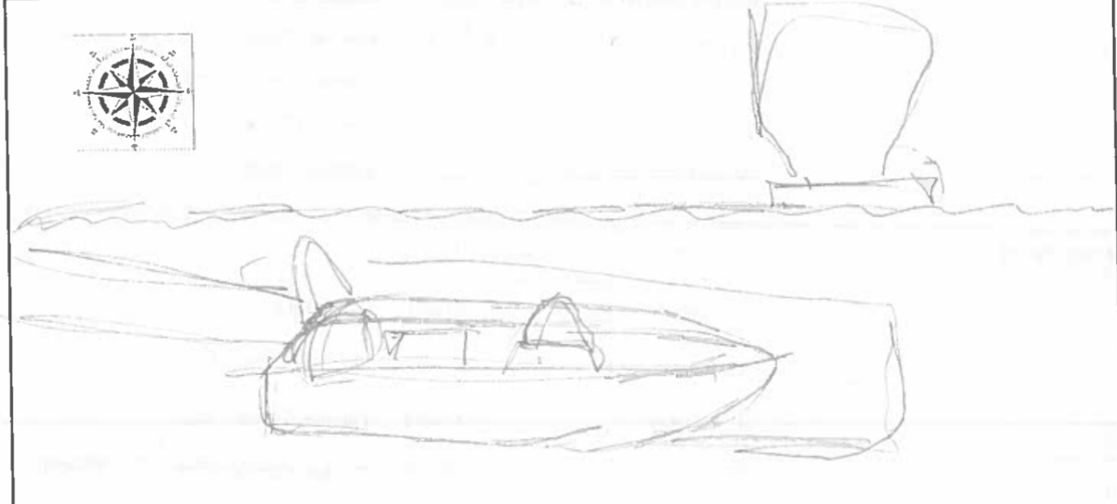
Location: Hudson River Park, Pier 40 (also called North River), Manhattan, NY
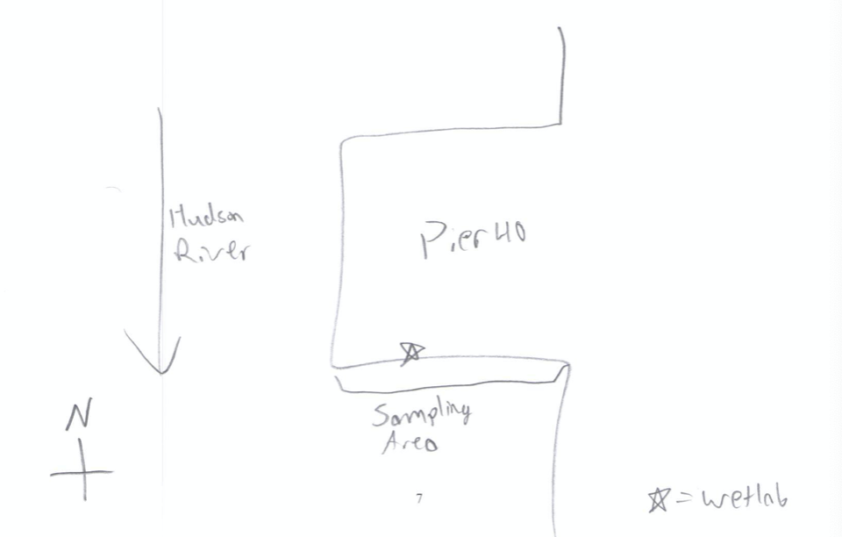
Area: Off southern side of Pier 40 about 600-800 feet down the pier from shore. Large urban pier with many sports facilities: athletic fields, kayaking and boathouse, seasonal moorings available, parking, fishing on the pier, benches and picnic tables for the public
Surrounding Land Use: 50% Urban/Residential; 50% Industrial/Commercial
Sampling Site: Pier, Bulkhead, banks altered; concrete and wood piling, large pier extends into river/cement bulkhead south ~100 m
Shoreline: Rocky
River Bottom: Soft sediment habitat, muddy
Plants in area: no plants in water area
Water: choppy, 15-20 ft
NOTE: this highly urban site is just west of the busy Westside Highway- it is the largest pier in Hudson River Park with a 14 acre footprint; Pier 40 is used for recreation, school groups using the athletic fields; there are 3 public boathouses; there are many people by the river’s edge jogging, biking, and walking.

ITEM |  | Time |  | Reading |  |  |  | Comments
Physical
Air Temperature |  | 10:30 AM |  | 18.4 º C |  |  | 65 º F
Wind Speed: |  | N/A |  | N/A
Weather today |  | 10:30 AM |  | 26-50% cloud cover |  |  | No Rain
Weather the past 3 days: |  | Fairly clear, warm, some light precipitation at night
Tides- |  | Time |  | Rising, Falling, Unchanged |  |  | Height (cm)
Measured change in depth of water at pier |  | 10:28 AM  11:03 AM |  | Rising  Rising |  |  | 328.3  361.3
Current- |  | Time |  | Cm/sec |  | Knots | North/South | Ebb/Flood/Still
 |  | N/A |  | N/A |  | N/A | N/A | N/A
Water Temperature- |  | 10:36 AM |  | 22.5 º C |  |  | 72.5 º F
Turbidity- Long sight tube |  | 10:30 AM  10:45 AM  10:55 AM |  | 39 cm  45 cm  53 cm
Chemical
Salinity- Students - Hydrometer |  | 10:33 AM |  | 13.6 ppt |  |  | Average reading
Salinity Standardized - Refractometer |  | 12:30 PM |  | 14 ppt
DO – chemets |  | Time |  | Temp |  |  | ppm DO | % saturation
 |  | 10:40 AM |  | 22º C |  |  | 6 ppm | 70%
pH – color match |  | 10:30 AM |  | 7
Nitrates- |  | N/A |  | N/A
Phosphates- |  | N/A |  | N/A
Biological
Fish |  | Number |  | Name |  |  | Length of longest | Length of smallest
 |  | 1  1 |  | Black sea bass  Oyster toadfish |  |  | 4.75 cm  8 cm
Fish Totals |  | TOTAL: 2 |  | Diversity: 2
Macroinvertebrates |  | Number |  | Name |  |  | Length of longest | Length of smallest
 |  | 2  16 |  | Blue Crab  Isopods (Idotea metallica) |  |  | 11 cm  1.2 cm | < 1 cm  < 1 cm
Macroinvertebrate Totals |  | TOTAL: 18 |  | Diversity: 2
Sediment Core
Length | H2S smell |  | Oxid Top |  | Oil |  | Grain Size | Other Features
N/A | N/A |  | N/A |  | N/A |  | N/A | N/A
Boats
 | Time |  | Name |  | Color |  | North/Southbound | Light/Loaded
Commercial | 10:56 AM |  | NY Waterway |  | White |  | North
 | 10:57 AM |  | Ferry |  | White/Blue |  | North
Residential

